What’s DNS and How It Works.

DNS (Domain Name System) is a system used to translate human-readable domain names into IP addresses

How it works:-

**DNS Query**: When a user types a website address into their browser, the browser sends a request (called a DNS query) to a DNS server to find the corresponding IP add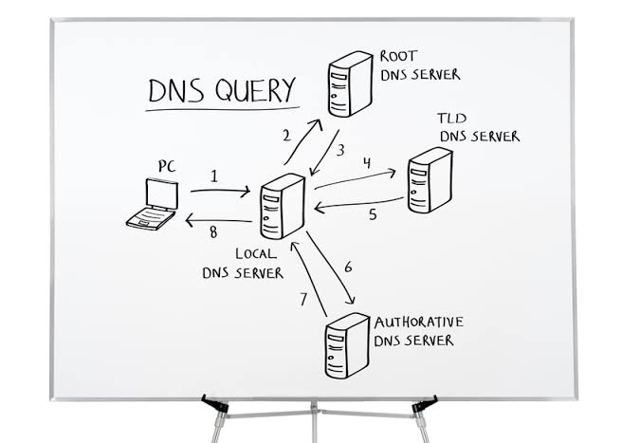

TCP vs HTTP

**بص يا بشمهندس، ببساطة خلينا نقول:**

**- **HTTP** (Hypertext Transfer Protocol) زي لما تبقى بتطلب حاجة من حد على الواتس آب مثلًا. أنت بتكتب "ممكن تبعتلي الصورة دي؟" واللي قدامك يرد عليك ويرسل الصورة. يعني، HTTP هو الطريقة اللي المواقع بتتكلم بيها مع بعض عشان تبعت وتستقبل بيانات زي الصور أو النصوص.**

**- **TCP** (Transmission Control Protocol) هو زي ساعي البريد اللي بيضمن إن الرسالة اللي أنت بعتها وصلت بشكل سليم وكامل. هو المسؤول عن تقسيم البيانات لأجزاء صغيرة، إرسالها، وبعد كده يجمعها تاني لما توصل للطرف التاني. والميزة الكبيرة في TCP إنه بيتأكد إن مفيش جزء من البيانات ضاع أو باظ في الطريق.**

**يعني:**

**- **HTTP** هو البروتوكول اللي بيقولك "إزاي تبعت وتستلم حاجات" على الإنترنت (زي طلبات صفحات الويب).**

**- **TCP** هو البروتوكول اللي بيضمن إن البيانات دي توصل سليمة وبالترتيب الصح.**

**فـ HTTP بيعتمد على TCP عشان كل حاجة تمشي مظبوطة.**

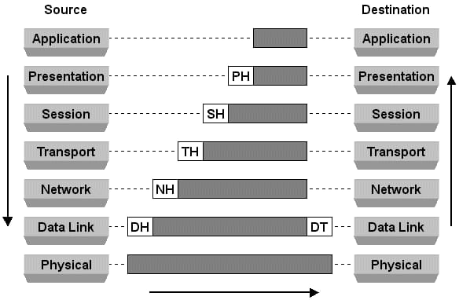

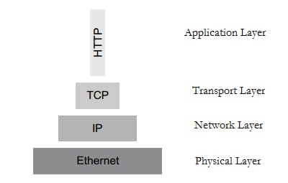

**HTTP vs HTTP**

**In short:**

**HTTP: Not encrypted, data is sent openly**

**HTTPS: Encrypted and secure, data is protected.**

**So, when you see the little lock icon next to the**

**website's URL (indicating HTTPS), it means your connection is secure, and your data is safe from prying eyes.**

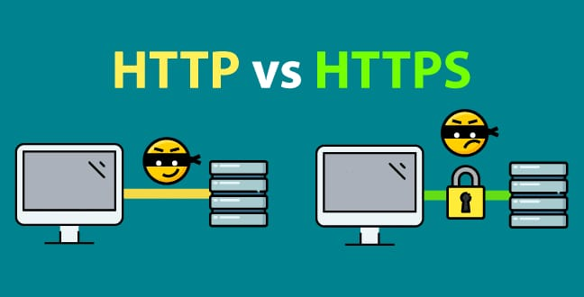

**DB vs File Based DB**

**Database (DB)**

**Structure: Data is stored in structured tables with relationships between**

**Querying: You can use complex queries (like SQL) to retrieve and manipulate data efficiently**

**Concurrency: Multiple users can access and modify data at the same time without conflicts**

**Security: Databases provide built-in security**

**features such as access controls and encryption**

**Scalability: Databases are designed to handle large volumes of data and can be scaled easily**

**Backup and Recovery: Databases usually automated backup and recovery options to prevent data loss.**

**File-Based Database:**

**Structure: Data is stored in simple files (like text or CSV) with no structured relationships between different sets of data**

**Querying: Limited querying options; often requires manual searching or basic scripting**

**Concurrency: It’s difficult to manage concurrent access, which can lead to data corruption if multiple users try to modify the file simultaneously**

**Security: Security depends on the file system, and there are limited or no built-in security mechanisms**

**Scalability: File-based systems struggle with large amounts of data and can become slow and inefficient**

**Backup and Recovery: Backups are manual, and there’s little support for automatic recovery**

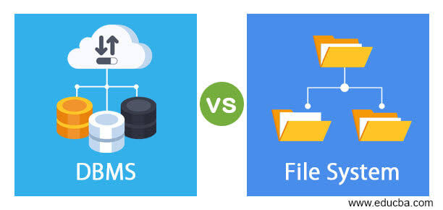 **types of databases**

**. 1­.Relational Databases (SQL)**

**2. NoSQL Databases**

**3. NewSQL Databases**

**4. Time-Series Databases**

**5. Graph Databases**

**6. Object-Oriented Databases**

**7. Column-Family Databases**

**8. Key-Value Stores**

**9. Hierarchical Databases**

**10. Distributed Databases**

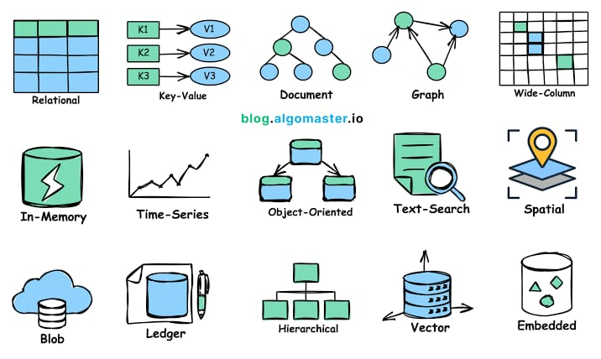

**SQL VS NOSQL**

**1_ Relational Databases (SQL)**

**SQL (Structured Query Language) databases are relational databases that use SQL to manage and manipulate structured data. They organize data into tables with rows and columns and support ACID (Atomicity, Consistency, Isolation, Durability) transactions.**

**2_** **NoSQL Databases**

**NoSQL databases are non-relational and designed for flexible data models, scalability, and handling large volumes of unstructured or semi-structured data. Types include**

**Document-Based: MongoDB, CouchDB**

**Key-Value Stores: Redis, Amazon DynamoDB**

**Column-Based: Cassandra, HBase**

**Graph-Based: Neo4j, Amazon Neptune**

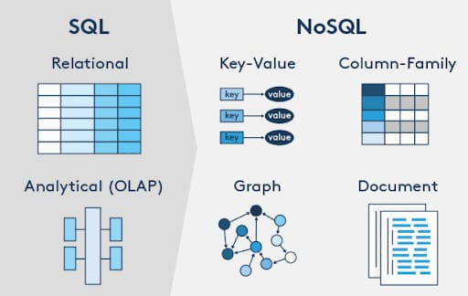 **OOP:** Object-Oriented Programming (OOP) is a programming paradigm based on the concept of "objects," which represent real-world entities. OOP is built around four main principles:

1. Encapsulation: Bundling data (attributes) and methods (functions) that operate on the data into a single unit or class, and restricting access to some of the object's components.

2. Inheritance: A mechanism where a new class (subclass) is derived from an existing class (superclass), inheriting its attributes and methods, allowing for code reuse and extension.

3. Polymorphism: The ability to process objects of different classes through a common interface, enabling one function or method to operate in different ways depending on the object it is acting upon.

4. Abstraction: The concept of hiding the complex implementation details and showing only the essential features of an object, allowing users to interact with the object at a higher level.

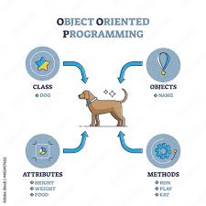

BY:Basma Deniour